Load three files:

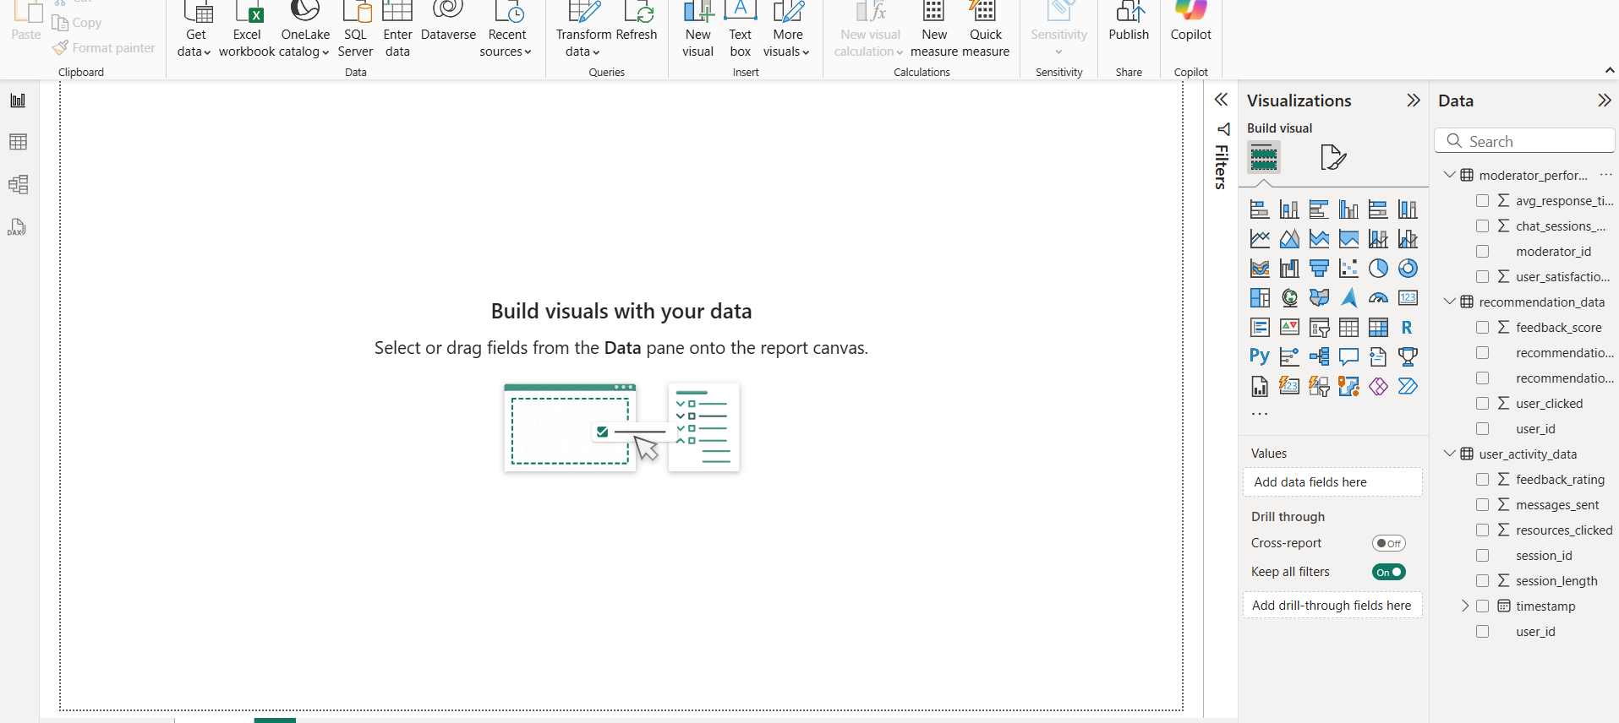

Data Preprocessing:

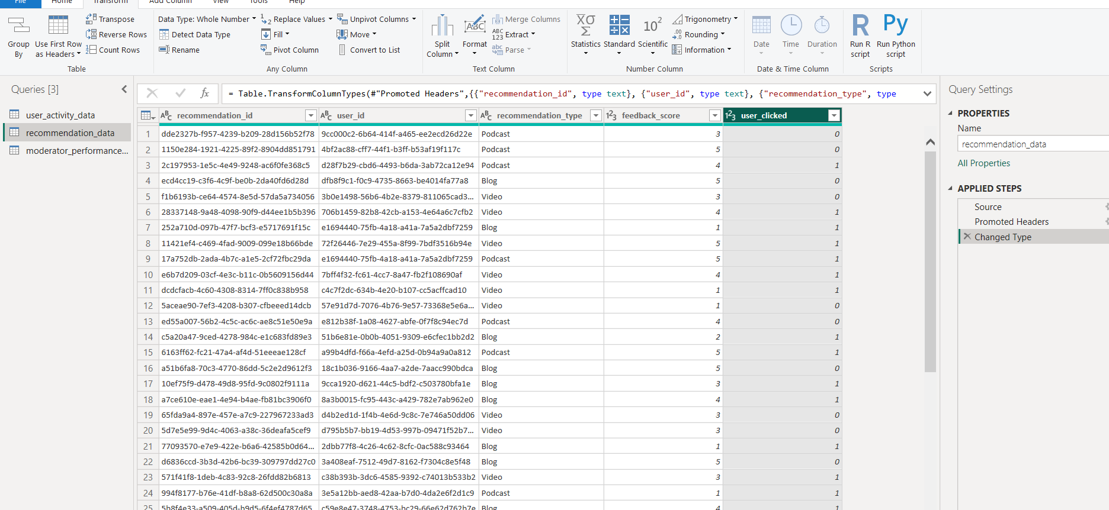

Modelling:

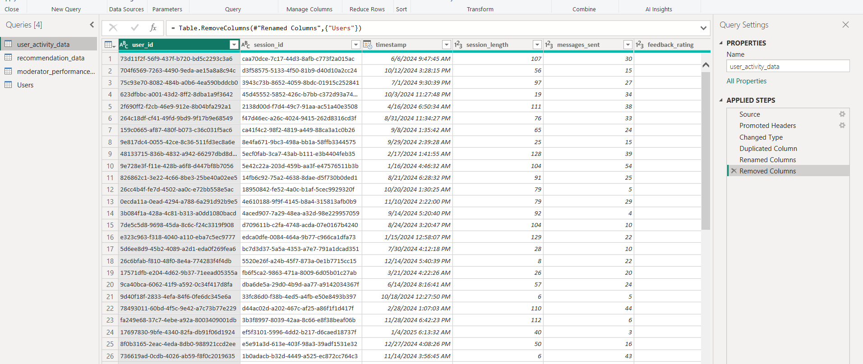

To avoid a Many-to-Many relationship between user tables, I created a Users bridge table with unique user IDs. This enables one-to-many relationships and clean filtering across user_activity_data and recommendation_data.

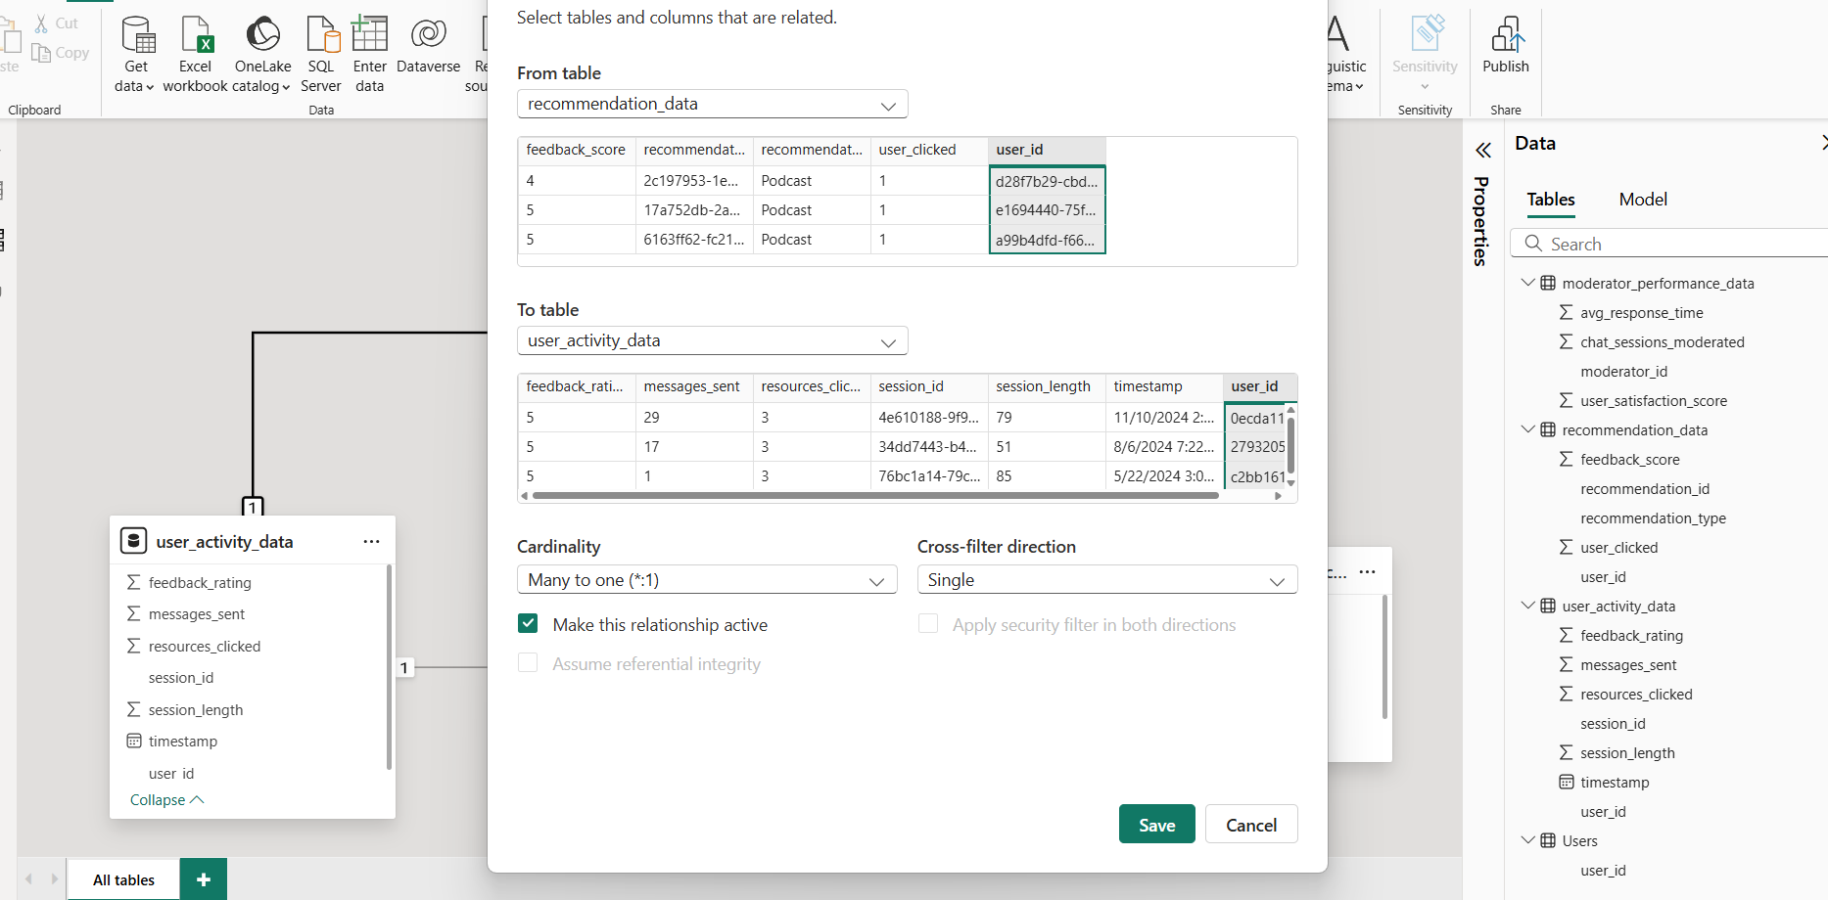

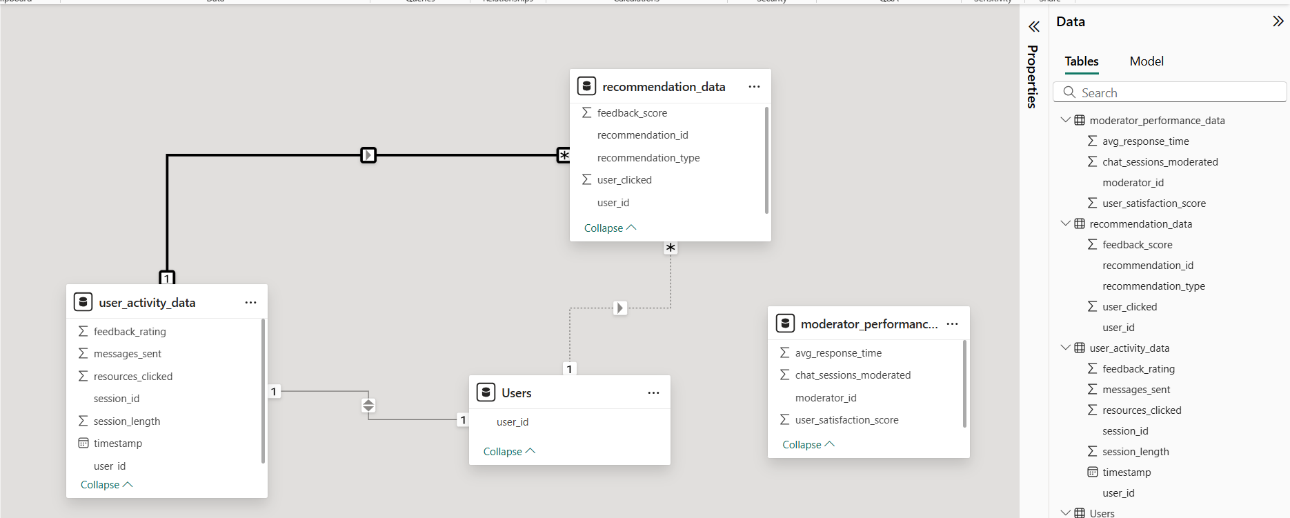

The moderator_performance_data table could not be connected to others because no table includes moderator_id. Therefore, I used it as a standalone dimension to analyze moderator KPIs. If moderator IDs were included in the session or user data, I would connect it to analyze moderator impact on user engagement and satisfaction.

Codes:

Avg Recommendation Feedback = AVERAGE(recommendation_data[feedback_score])

Click rate = DIVIDE(SUM(recommendation_data[user_clicked]), COUNT(recommendation_data[recommendation_id]))

Avg Feedback = AVERAGE(user_activity_data[feedback_rating])

Avg Messages = AVERAGE(user_activity_data[messages_sent])

Avg Resorce = AVERAGE(user_activity_data[resources_clicked])

Avg Session Length = AVERAGE(user_activity_data[session_length])

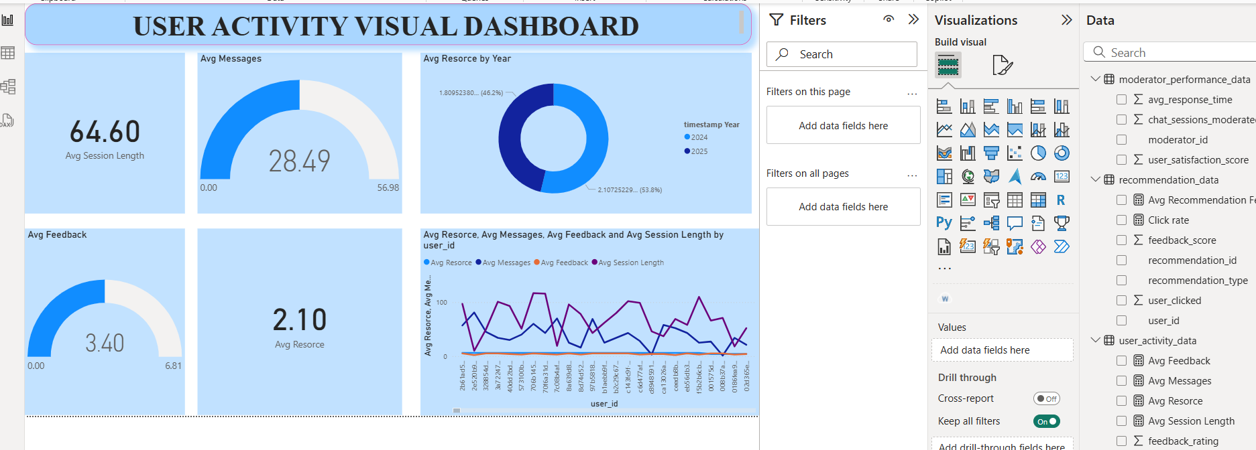

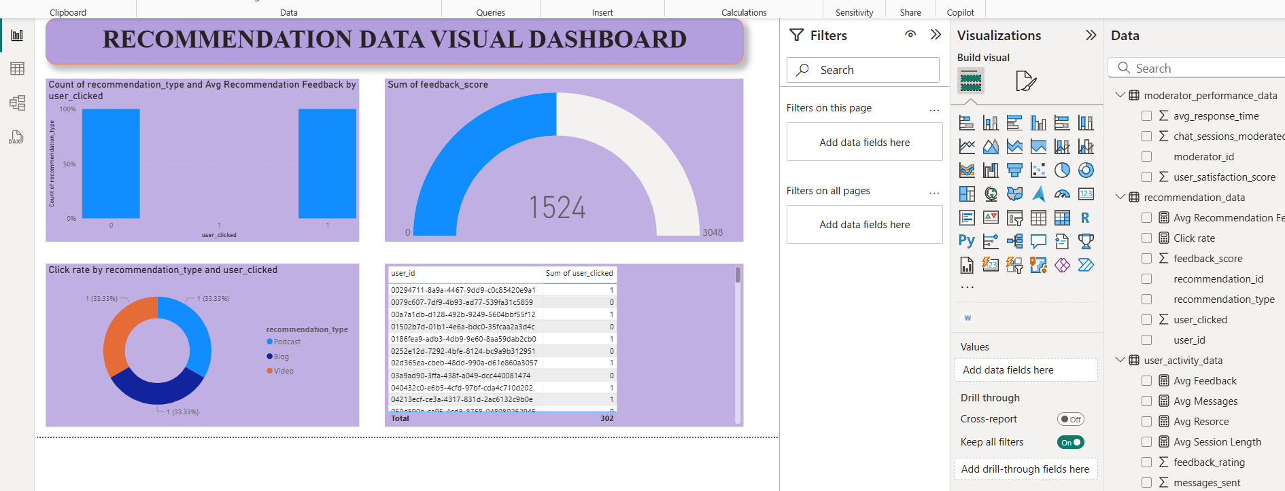

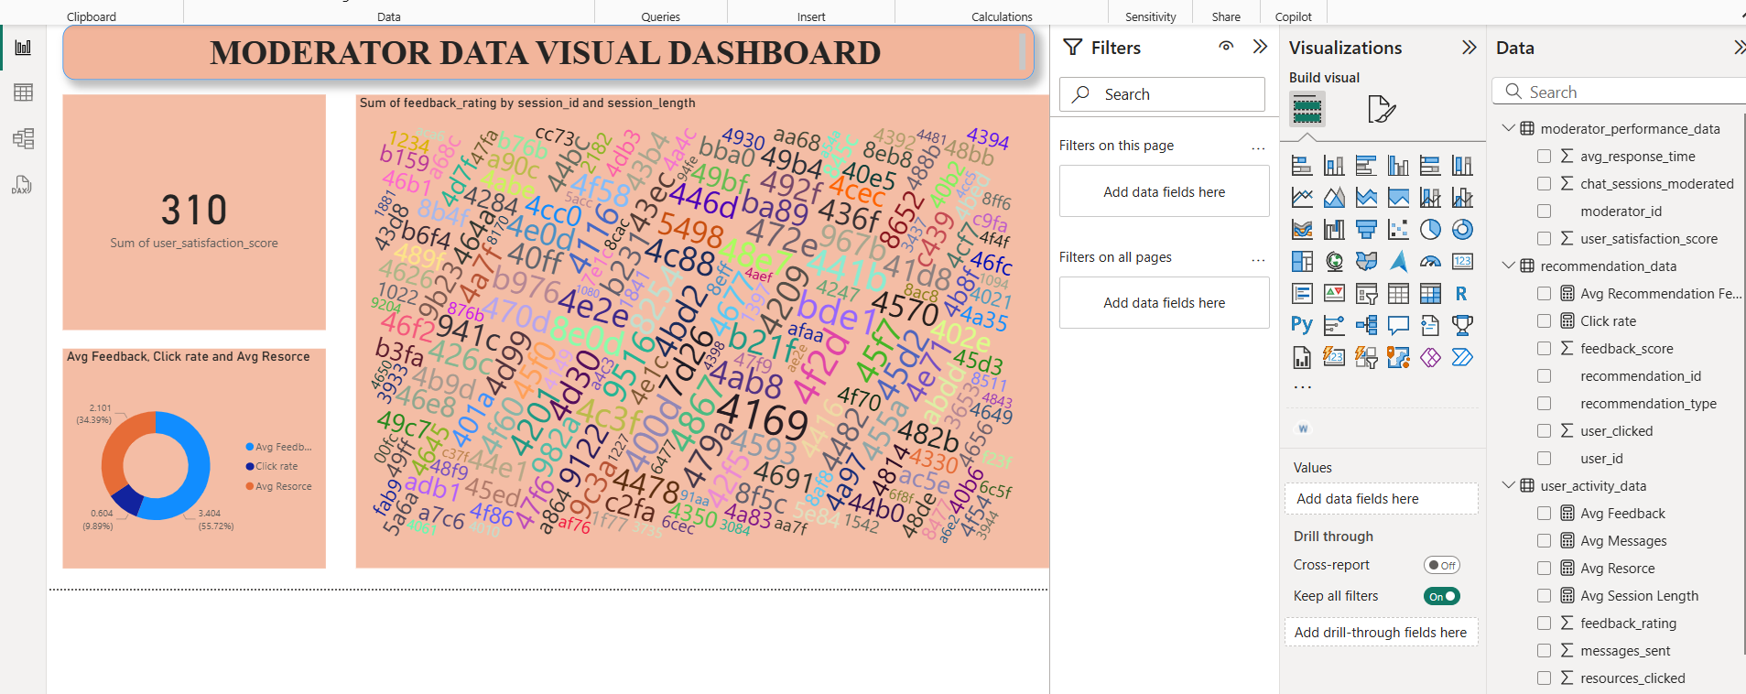

Analyzing User Engagement, Recommendations & Moderator Performance

Goal:

To help Supportiv’s leadership team make data-driven decisions by exploring user session patterns, recommendation performance, and moderator metrics. The aim is to uncover key trends, define engagement KPIs, and provide actionable business recommendations.

1. Ingest & Transform:

* Loaded 3 CSV datasets in Power BI.
* Cleaned nulls, ensured proper data types.
* Created a Users table to unify user_id across datasets.
* Relationships built: Users ↔ user_activity_data, Users ↔ recommendation_data.

2. Cross-Dataset KPIs (Created using DAX):

User Engagement (from user_activity_data):

* Avg Session Length: 64.6 minutes
* Avg Messages Sent: 28.49
* Avg Feedback Rating: 3.4
* Avg Resources Clicked: 2.10

Moderator Metrics (from moderator_performance_data):

* Total Satisfaction Score: 310
* Avg Response Time per Moderator
* Word (I uploaded it)

Recommendation Effectiveness (from recommendation_data):

* Click-Through Rate (CTR): ~19.8%
* Avg Feedback on Recommendations: 3.40
* CTR by Type: Evenly split across Video, Blog, Podcast (33.3% each)

Business Insights

What insights can you uncover?

* Users who spend more time and send more messages tend to leave better feedback.
* Feedback ratings tend to be higher when more resources are clicked.
* Recommendation types show similar click rates, but user satisfaction differs slightly.

How would you measure engagement or effectiveness?

* Engagement: Avg session length, messages sent, feedback rating.
* Moderator Effectiveness: Satisfaction score vs response time.
* Recommendation Effectiveness: CTR, Word and feedback score by type.

What trends or patterns stand out?

* Avg feedback aligns positively with session length.
* CTR is consistent across recommendation types, suggesting potential to personalize based on user behavior instead of random suggestions.
* Some moderators have long response times with low satisfaction scores — indicating training opportunities.

Are there areas of concern or anomalies?

* Click rate is lower than 25% on average — this may indicate poor recommendation targeting.
* No direct link between moderators and sessions (missing moderator_id in session data) limits further analysis.

Improve the Data for Future Analysis

If we collect more details like which moderator helped in each session, we can do deeper analysis next time and give better business advice.